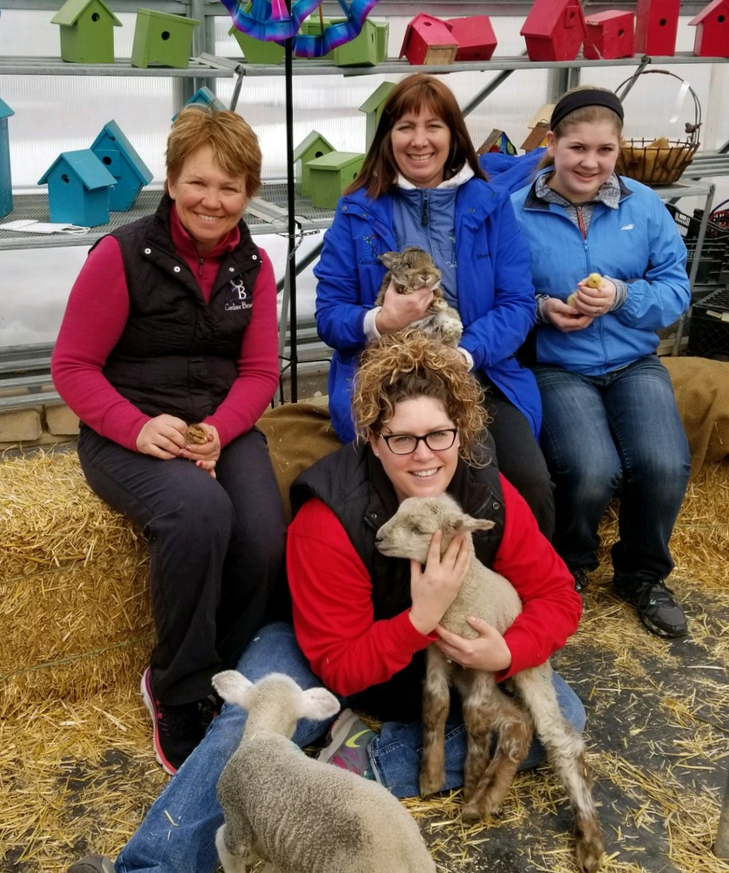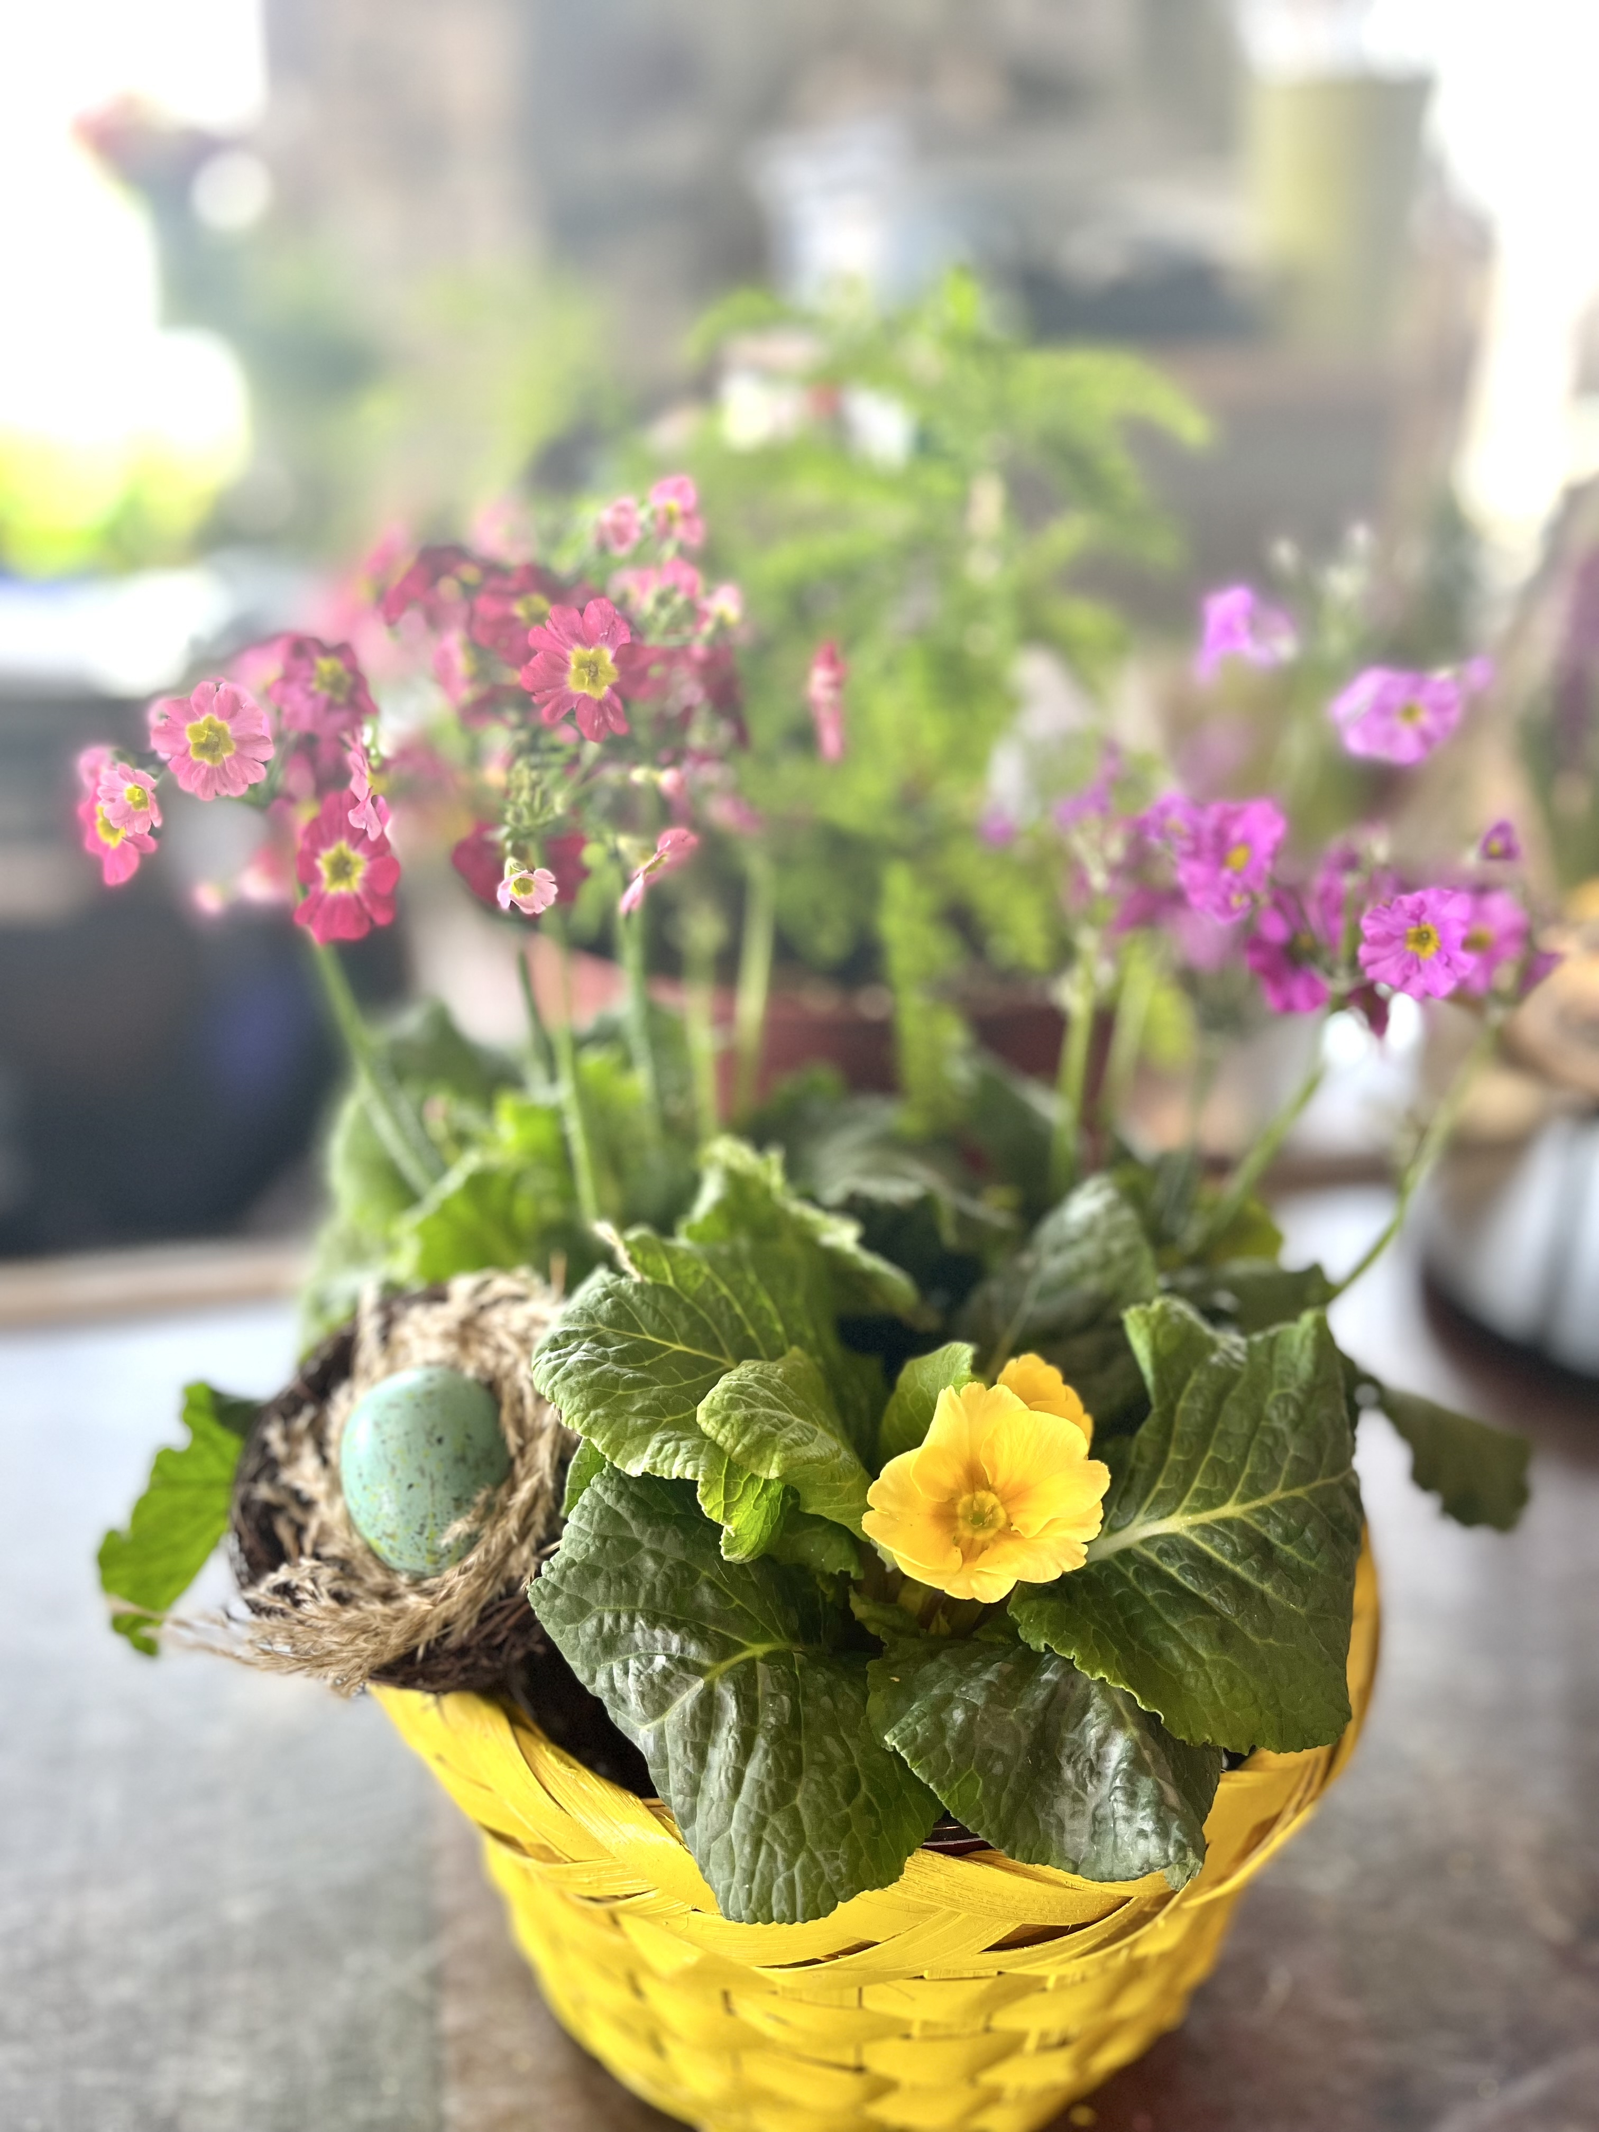  Spring Fun Day  We have rice krispie treats in the building with juice and coffee.  Easter Decorating items 50% off.  4” Primula, Primrose, Gerbera $3.99.  With spring pastel wood box $15.00. Save $2.00  Purchase a bird house or feeder for spring receive FREE Thistle Feed.  15% off all other bird food  Coupon good April 16th- April 22nd.  While supplies last, not to combine with any other discount or ad.  All 2” Mini Cyclamen, Violet, Rose and Calandiva are on Sale $3.99. Save $2.00.  2” Mini Green plants in coffee cup pot $7.99  Buy Candyl Portable Oil Diffuser with timer and get your first fragrance oil for $6.99 saving 50% off.  Coupon good April 16th.  While supplies last, not to combine with any other discount or ad. | 10:00 - 4:00 Easter egg hunt in Lily Jo Gardens  Sales Building See baby Chicks and Ducks  Greenhouse 2 Decorate a paper bag to use for egg hunt and prizes. Plant a violet in a pot to take home to grow for spring.  ────  Outside lot Lambs, Goats, Bunnies to pet  ────  Treats Sponcerd By  Coborn’s Grocery Store  Melissa Kreuser  American Family Insurance

